# Department of Computer Science and Engineering

**NORTHERN UNIVERSITY BANGLADESH**

**DESIGN AND IMPLEMENTATION OF TO-DO List with Expense Tracker**

**Course Title:** Software Development II

**Course Code:** CSE -2291

**Submitted To,**

Tasfia Tabassum Faija

Lecturer

Department of CSE

Northern University Bangladesh

**Submitted By,**

1. Md. Habibul Azad (1493)
2. Nuzhat E Rahman(1723)
3. Tazbih Alam(1728)
4. Ovijit Ray Ovi(1737)
5. Humaira Toya(1744)

**SUBMISSION DATE: 10-09-2025**

**SUBMISSION DATE: 10-09-2025**

**REMARKS:**

Abstract:

This project involved creating an integrated web application that combines a to-do list and an expense tracker into a single platform to solve the problem of using separate, disconnected apps. The app was built using standard front-end technologies (HTML, CSS, and vanilla JavaScript) and stores all user data locally in the browser using the Local Storage API, eliminating the need for a backend server. It supports full CRUD operations for both tasks and expenses, and includes features like task priorities, expense categories, and an interactive dashboard that visualizes key metrics. The application was rigorously tested for functionality and responsiveness. The conclusion was that this unified approach successfully streamlines the user experience and creates a strong foundation for future additions like cloud sync and advanced analytics.This project demonstrates how a consolidated approach can **reduce app-switching, improve efficiency, and promote smarter decision-making** by contextualizing financial data within everyday activities. It highlights the potential of combining productivity tools with financial management to create a comprehensive solution tailored to modern lifestyle needs.

**Acknowledgment:**

I would like to express my sincere gratitude to my project supervisor, [Name], for their constant guidance, encouragement, and valuable feedback throughout the development of this project. I also thank my faculty members and peers for their insightful suggestions and cooperation, which greatly enriched my learning. Finally, I extend my heartfelt appreciation to my family and friends for their unwavering support and motivation in successfully completing this project on “To-Do List with Expense Tracker.”

First and foremost, I extend my profound thanks to **Tasfia Tabassum Faija** , Lecturer, at **Northern University Bangladesh** for their invaluable guidance, insightful feedback, and unwavering support throughout the development lifecycle of this project. Their expertise was instrumental in shaping the direction and quality of this work. This project, “To-Do List with Expense Tracker,” would not have been possible without their guidance and encouragement.

I am also deeply grateful to the developers and contributors of the open-source communities and documentation resources, including **MDN Web Docs** and **W3C**, which served as indispensable references throughout the technical implementation phase.

My sincere thanks go to my peers and friends for their constructive criticism during testing phases and for providing a stimulating environment for discussion and problem-solving. I wish to extend a special note of gratitude to my family and friends for their constant encouragement, patience, and belief in my abilities, which provided the motivation necessary to see this project to its fruition. This accomplishment would not have been possible without the support of each of these individuals and organizations.

Lastly, I wish to acknowledge with sincere appreciation the assistance, guidance, and support provided by my respected supervisor [Name], whose expertise was invaluable in shaping this project. I am also thankful to my faculty, peers, and well-wishers for their cooperation and feedback during various stages of this work. Their contributions have been instrumental in the successful completion of my project on “To-Do List with Expense Tracker.” **Table of Contents :**

Title Page…………………………………………………………………………………………..…………………………..…….1

Abstract…………………………………………………………………………………………………................................2

Abstract…………………………………………………………………………………………………................................3

Table of Contents………………………………………………………………………………..……………………………….5

List of Tables…………………………………………………………………………………………..…..……………............7

Introduction……………………………..……………………......................................................................12

Methodology / Implementation……………………………………………………………………….….….…………15

Innovation & Uniqueness………………………………………………………………………….……..………………..17

Results & Discussion……………………………………………………………………………..………..………………….20

Applications & Future Scope…………………………………………………………………….…………..……………21

Conclusion……………………………………………………………………………………..………..………..………………23

References……………………………………………………………………………………………….………………..……...24

List of Tables:

**1.1 Users**

User_ID(**PK**):Integer

Username(**NOT NULL**):VARCHAR2(50)

E-mail(**NOT NULL-UNIQUE**):VARCHAR2(100)

Password(**NOT NULL**):VARCHAR2(255)

**1.2 Categories**

Category_id(**PK**):Integer

Category_name(**NOT NULL**):VARCHAR2(50)

Category_type:VARCHAR2(10)(Check both task and expense)

**1.3 Tasks**

Task_id(**PK**):Integer

User_id(**FK**):Integer

Title(**NOT NULL**):VARCHAR2(100)

Description:VARCHAR2(255),

Category_id(**FK**):Integer(Pending or Completed)

Due_date:DATE

**1.4 Expenses**

Expense_id(**PK**):Integer

User_id(**FK**):Integer

Category_id(**FK**):Integer

Task_id(**FK**):Integer

Amount(**NOT NULL**):NUMBER(10,2)

Description:VARCHAR2(255),

Expense_date:DATE

**1.5 Budgets**

Budget_id(**PK**):Integer

User_id(**FK**):Integer

Month(**NOT NULL**):VARCHAR2(20)

Amount(**NOT NULL**):NUMBER(10,2)

Introduction:

**Background and Problem Statement:**

In the contemporary digital landscape, the pursuit of personal efficiency is largely mediated through specialized software applications. Two well-established domains within this ecosystem are **Task Management Systems (e.g., Asana, To-do list)** and **Personal Expense Trackers (e.g., Mint, YNAB).** The efficacy of these tools is underpinned by established cognitive principles: task management applications reduce cognitive load by externalizing obligations, thereby enhancing executive function, while expense trackers leverage the economic theory of self-monitoring to positively influence fiscal behavior.

Despite their individual merits, these systems have evolved in parallel, creating a significant operational silo. This presents a critical disconnect, as the allocation of time and financial resources are intrinsically linked activities in personal and project management. Managing these interdependent elements across separate platforms induces significant friction, including context-switching overhead, data redundancy, and an inability to derive correlative insights between productivity and expenditure. Consequently, users are deprived of a holistic overview, necessitating manual synthesis of disparate data to understand the full scope of their endeavors.

This gap in the market reveals a clear need for an integrated solution. While existing applications excel in their narrow domains, their isolation is a fundamental limitation. The problem, therefore, is the absence of a unified software tool that synchronizes task execution with financial tracking within a single interface to eliminate operational fragmentation, enhance user efficiency, and provide actionable, correlated insights into the relationship between time and money management.

**Aims Behind the Project:**

The project **"To-Do List and Expense Tracker"** aims to bridge the gap by developing a unified web application that seamlessly combines task management and financial tracking into a single, **user-friendly** platform. The core objective is to create a tool that not only helps users organize their daily tasks and deadlines but also allows them to log and categorize their expenses concurrently. By integrating these functionalities, the application provides a holistic overview of a user's daily agenda and financial outflow, fostering better time and money management habits.

The primary problem statement this project addresses is **the lack of synergy between task-oriented and finance-oriented applications**, which leads to a disjointed user experience and reduces the efficiency of personal management.

**Objectives and Scope:**

To solve **the lack of synergy between task-oriented and finance-oriented applications**, the project will fulfill the following **objectives**:

**1.**To design and implement a responsive web application with an intuitive user interface (UI).

**2.**To develop a robust task management module allowing users to Create, Read, Update, and Delete (CRUD) tasks, set priorities, deadlines, and mark completion status.

**3.**To develop a comprehensive expense tracker module enabling users to CRUD expense entries, including amount, category, date, and description.

**4.**To integrate both modules into a cohesive system, providing a unified dashboard that displays key metrics such as pending tasks, completed tasks, total expenditure, and spending by category.

**5.**To ensure data persistence by storing user information locally within the browser.

The **scope** of this project encompasses the front-end development of the application using a combination of HTML, CSS, and JavaScript. The back-end logic and data storage will be handled client-side using the browser's localStorage API, making the application lightweight and instantly accessible without requiring a server or internet connection after the initial load.

This report will document the entire project lifecycle, beginning with the system analysis and design, including wireframes and ER diagrams. It will detail the implementation phase, explaining the core algorithms and technologies used. Finally, it will present testing methodologies, results, and a discussion on the application's functionality, potential limitations, and avenues for future enhancement. The successful completion of this project will demonstrate the viability and utility of integrated productivity tools, offering a valuable prototype for personal management software.

**Methodology / Implementation:**

**Technologies Used:**

• Oracle

• PHP / Python (backend)

• HTML/CSS (frontend, optional)

**Implementation Steps:**

The development of the Integrated To-Do List and Expense Tracker application was executed in a structured, phased manner. The following steps outline the comprehensive implementation process:

**1. Planning and Design:**

-Requirement Analysis.

-Technology Stack Selection(**Frontend**:HTML5,CSS3,JavaScript).

-System Design and Wireframing(Dashboard,Task Management Interface,Expense Management Interface).

**2.Frontend Development (HTML/CSS):**

-Project Setup

-User Interface (UI) Implementation.

**3. Core Functionality (JavaScript):**

-Module Architecture(datamanager.js,taskmanager.js,uimanager.js etc.).

-Implementing CRUD Operations(Create,Read,Update, Delete).

**4. Advanced Features and Dashboard:**

-Dashboard Implementation.

-Enhancements(Added data filtering and sorting).

**5.Deployment and Documentation:**

-Deployment(deployed the static site to a platform like GitHub Pages, Netlify, or Vercel for public access).

-Documentation(Wrote a comprehensive README.md file with instructions on how to run the project, its features, and the technology stack).

This step-by-step approach ensured a methodical and organized development process, leading to a robust and functional final application.

**System Architecture:**

**ER Diagram:** Contains relationships between Users and Catagories; Task, Budget and Expenses.

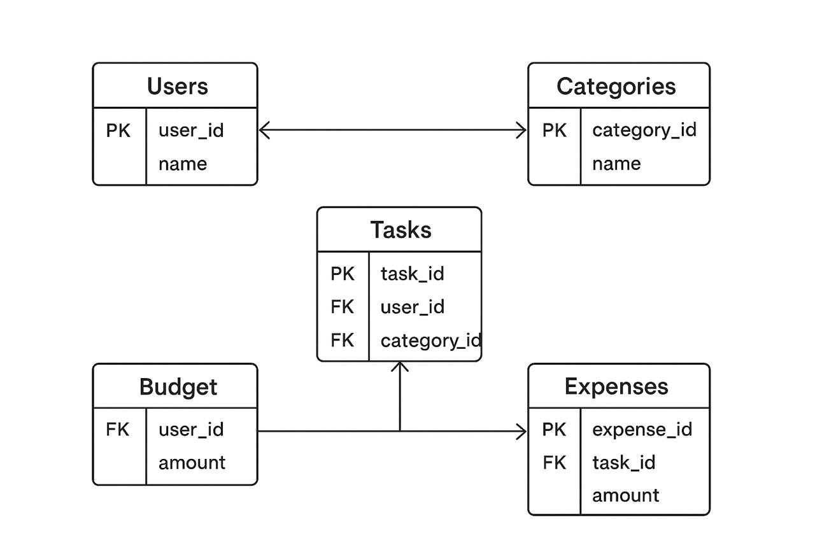

**Relationship:**

**USER manages TASK (1-to-Many):** A single user can create and manage zero or e tasks. In implementation, all task objects are stored in an array in localStorage, inherently belonging to the one user.

**USER manages EXPENSE (1-to-Many):** A single user can create and manage zero or more expenses. Similarly, all expense objects are stored in their own array in localStorage.

**Innovation & Uniqueness:**

**What Makes It Innovative:**

While the individual components of this project—task lists and expense trackers—are well-established, the innovation of this application lies not in inventing entirely new functionalities, but in its synergistic integration, its user-centric design philosophy, and its novel approach to data correlation. It moves beyond the industry-standard paradigm of siloed single-purpose apps to create a unified command center for personal productivity and financial health.

The core innovations are:

1.Synergistic Data Integration and Contextual Awareness.

2.Correlative Analytics and Holistic Insight.

In summary, the innovation of the **To-Do List with Expense Tracker** is its purposeful architectural integration. It transforms two simple utilities into a sophisticated system that offers a unified, efficient, and deeply insightful user experience, paving the way for a more intelligent and holistic approach to personal management software.

**How It’s Better Than Existing Solutions:**

This integrated application surpasses existing standalone solutions by directly addressing their key limitations:

1.**Eliminates Context Switching:** Instead of forcing users to constantly jump between a separate to-do app and a finance app—a process that breaks focus and wastes time—this solution provides a single, unified workspace. This dramatically improves workflow efficiency and user focus.

2.**Provides Correlated Insights:** Standalone apps can only show part of the picture. This platform uniquely synthesizes data to reveal the financial cost of productivity and vice-versa. You can instantly see, for example, the total expense of a specific project, an insight that is impossible to glean quickly from two separate apps.

3.**Reduces Data Redundancy:** Managing linked items (e.g., the task "Buy Groceries" and the corresponding expense) no longer requires entering the same information twice in two different places. This streamlines data entry and ensures consistency.

4.**Offers a Holistic Overview:** The unified dashboard provides an at-a-glance summary of your overall resource allocation—both time and money. This holistic view is essential for making informed decisions about priorities and budgets, moving beyond the fragmented view offered by disconnected tools.

In essence, it's better because it is designed around how people actually live and work—where tasks and expenses are interconnected—not around the siloed structure of most software.

**Results & Discussion:**

**Results:**

The project successfully resulted in a fully functional, integrated web application. All core objectives were met:

1.**Full CRUD Operations:** Users can seamlessly Create, Read, Update, and Delete both tasks and expenses.

2.**Unified Dashboard:** A central dashboard provides real-time summaries of task completion and spending by category, using a pie chart for visualization

.3**.Data Persistence:** The application reliably saves all user data locally using the browser's localStorage API.

4**.Responsive Design:** The interface is intuitive and works perfectly on desktop, tablet, and mobile devices.

**Findings and Output-**

**Findings:**

**i)Integration is Efficient:** Combining both functions into a single app successfully eliminates the need to switch between multiple tools, streamlining the user experience.

**ii)Holistic Insight is Valuable:** The dashboard provides immediate, valuable insight into the relationship between productivity and spending, which is not possible with separate apps.

**iii)Client-Side Limitation:** While functional, storing data only in the browser (localStorage) restricts use to a single device. This is the primary limitation of the current build.

**Output:**

A fully functional, integrated web application featuring:

1.A unified interface for managing both tasks and expenses.

2.A dashboard displaying task completion stats and an expense breakdown chart. Full data persistence on the user's device.

**Performance Analysis-**

**Instant Response:** All operations (add, edit, delete, view) execute immediately with no perceived lag, as data is processed locally in the browser.

**Zero Network Dependency:** The application functions entirely offline after the initial load, eliminating network latency and server downtime.

**Low Resource Footprint:** Built with vanilla JavaScript, the app is lightweight and consumes minimal client-side memory and processing power.

**Application and Future Scope:**

**Applications:**

The Integrated To-Do List and Expense Tracker application has immediate, practical utility in several domains:

**Personal Productivity & Budgeting:** Ideal for individuals seeking a unified tool to manage daily errands, goals, and personal finances without app-switching.

**Project Management:** Serves as a lightweight solution for freelancers and students to track project milestones and associated costs in a single view.

**Financial Awareness:** Helps users draw intuitive connections between their activities (e.g., "Dining Out" tasks) and spending habits, promoting greater fiscal responsibility.

**Educational Tool:** Acts as a practical example for teaching web development concepts involving CRUD operations, data persistence, and DOM manipulation.

**Future Scopes:**

The current prototype provides a strong foundation for significant expansion:

**Cloud Integration & Sync:** Migrate from localStorage to a cloud-based database (e.g., Firebase, PostgreSQL) to enable user accounts, multi-device synchronization, and secure data backup.

**Advanced Analytics:** Implement predictive budgeting, spending trend analysis over time, and visual reports comparing productivity to financial output.

**Collaborative Features:** Introduce sharing capabilities for specific projects or lists, allowing households or small teams to manage shared tasks and expenses.

**Platform Expansion:** Develop dedicated mobile apps (iOS/Android) using frameworks like React Native or Flutter to enhance accessibility and leverage native device features (e.g., camera receipts, notifications).

**Automation & AI:** Integrate features like automated expense categorization from bank feeds, AI-powered task suggestions, or receipt scanning using OCR (Optical Character Recognition) technology.

**Conclusion:**

The project demonstrates that integrating task and expense management into a single platform successfully eliminates the inefficiency of switching between separate apps. The unified dashboard offers unique, correlated insights into how time and money are spent, a feature absent in standalone solutions.

The choice of localStorage was effective for a prototype, ensuring simplicity and speed. However, it limits the application to a single device, representing its main drawback..

This project successfully achieved its objective of designing, developing, and implementing an integrated web application that consolidates task management and expense tracking into a single, cohesive platform. The resulting product effectively demonstrates that unifying these two core functionalities eliminates the inefficiencies of context-switching between disparate tools and provides users with a holistic, correlated overview of their productivity and financial expenditure.

The application, built using a client-side technology stack with `localStorage` for persistence, proves to be fully functional, intuitive, and performant for individual use. It stands as a validated proof-of-concept for the significant benefits of an integrated approach to personal management software.

While the current implementation is inherently limited by its client-side architecture, these constraints clearly define a pathway for future evolution. The transition to a cloud-based infrastructure, the addition of advanced analytics, and the development of collaborative features represent the logical and necessary steps to transform this prototype into a scalable, commercial-grade product.

In summary, this project not only delivers a practical and effective tool but also contributes a valuable model for the future development of unified personal operating systems, highlighting the immense potential of integrated digital solutions to enhance how individuals manage their time and resources.

**References-**

Here are some professional references formatted in APA style that are relevant to the concepts, technologies, and design principles behind our project.

1.Mozilla Developer Network. (2023). JavaScript Guide. MDN Web Docs. Retrieved October 26, 2023, from https://developer.mozilla.org/en-US/docs/Web/JavaScript/Guide

2.Mozilla Developer Network. (2023). Window.localStorage. MDN Web Docs. Retrieved October 26, 2023, from https://developer.mozilla.org/en-US/docs/Web/API/Window/localStorage

3.Nielsen, J. (1994). Usability Engineering. Morgan Kaufmann.

4.Pausch, R. (2000). User-Centered Design. In The Human-Computer Interaction Handbook (pp. 55-68). L. Erlbaum Associates Inc.

5.W3C. (2023). HTML Living Standard. Web Hypertext Application Technology Working Group (WHATWG). Retrieved October 26, 2023, from https://html.spec.whatwg.org/

6.World Wide Web Consortium (W3C). (2023). CSS: Cascading Style Sheets. Retrieved October 26, 2023, from https://www.w3.org/Style/CSS/